Group: InfoBoss

Hai Anh Le, Songyun Qian, Krishna Ghorpade, Jeel Joshi, Divya Pakhale

CIS 5040

Professor Arun Aryal

5 Dec, 2017

Group Project Report – InfoBoard

1. Framing

In the modern days, when technology is basically taking over many corners and aspects of life, people’s communication to each other declines over time. Instead of finding a solution to increase the interaction between humans, as business entrepreneurs and computer engineers, we would like to take advantage of this phenomenon. We would like to enhance such behaviors by designing a device that saves people’s time and increases the efficiency of the individuals who use it. In order to narrow down the scope, we have decided to experiment the product within our college campus. Hence, the content and interfaces of the device will serve specific needs of the students on campus. If the product is a success, we would hope that in the future, it would be utilized and developed by bigger companies and organizations.

1. Introduction of the project

It is a wonderful opportunity which the professor gives the freedom to each group of students to come up with original ideas and manage their own times to work on it. After brainstorming, we came up with the name InfoBoss for our group. It is to start the project with confidence and motivate us to stay true to our major: Information Systems. Having been able to frame potential opportunities as mentioned above, we came up with the idea of an electronic board that could be installed around campus. The board initially was designed to minimize the students’ efforts to look up information without logging into their school portal and to increase their engagement amongst events and activities on campus. We named it as InfoBoard. This product is considered as a minuscule prototype for possible future technologies such as an entrance device in front of a supermarket that help shoppers look for what they want more easily. We want to test the product usability and functions through this graduate class project. Moreover, to specify the contents of this electronic board, we have exclusively conducted market research and design research. Details of the research methods would be explained as below.

1. Analysis

To begin the research process, our group has utilized the Design Research model as in Figure 1 below. It is a useful tool to define which step to start with and move along in details to approach the end results. We also used the classroom material that the professor provided us to enhance the process. The layout of this Analysis section is in accordance to the material our professor shared with us that includes 7 stages of a design process.

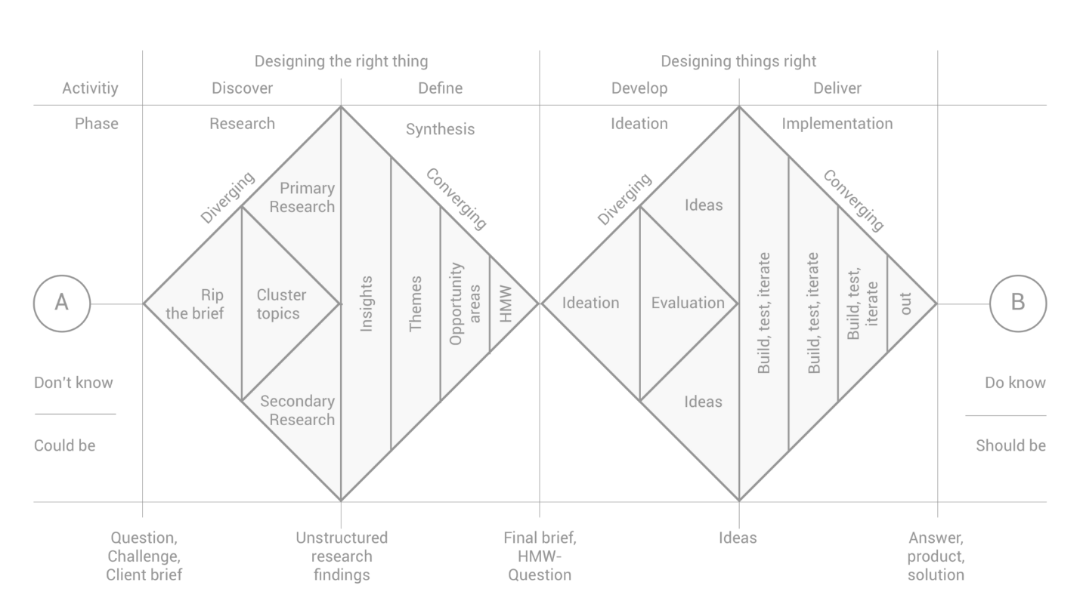Figure 1. Research Design model by Dan Nessler, UX director.

1. Market research
2. Facts

We are building a product and software that will serve the needs of the students on campus. Relating to the Design model above, it will be “Rip the brief”. We created a survey with five short questions on Survey Monkey. Since our group has five students, we determined to each get 20 responses from students on campus. Each of us would go to most populated areas on campus such as the cafeteria, the library, and the walkway to survey students. We also utilized social media as such Facebook groups of different student organizations. The questions are as Figure 2 below. We designed five questions to identify the student’s class standing, preference in which information they would want to look for, what they would use the InfoBoard for, and whether they would recommend it to other people.

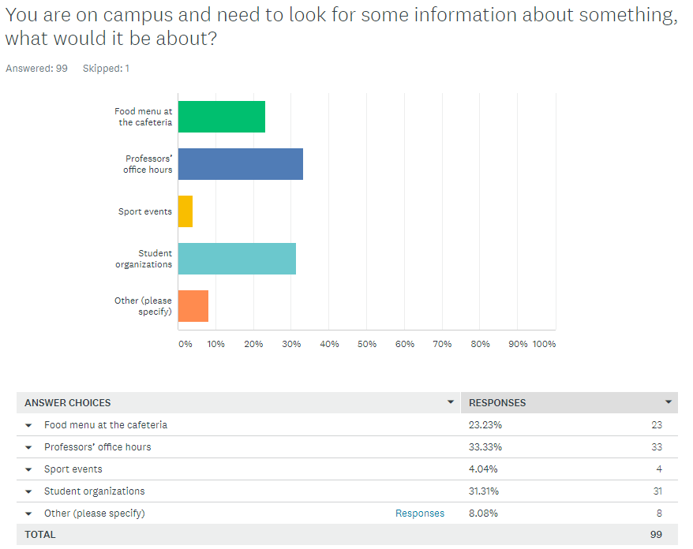

Figure 2. Results of 2 out of 5 Survey Monkey Questions

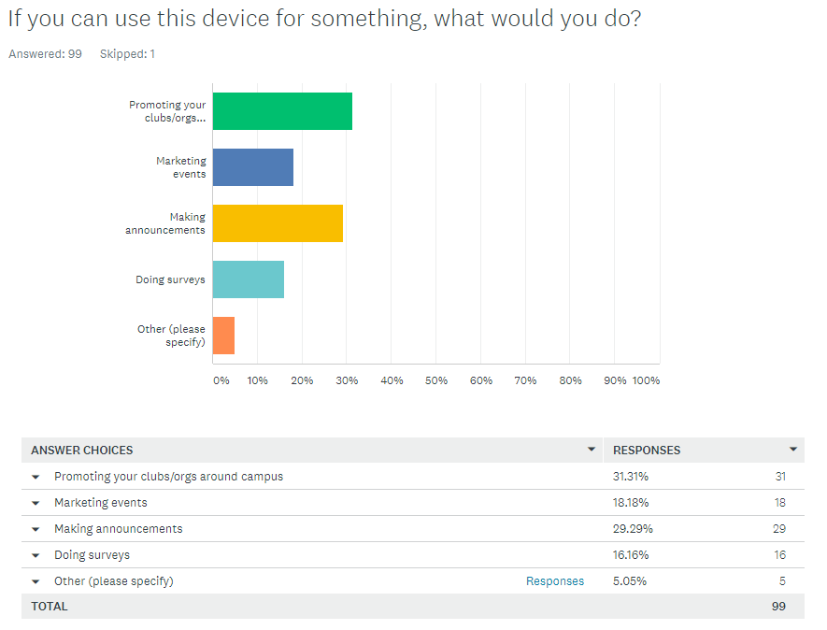

Figure 3. Results of 3 out of 5 Survey Monkey Questions

1. Themes

Our team was able to collect 100 responses after one week of doing the survey. This type of survey is primary research and we were able to collect cluster topics (according to the Design Research terminologies). The results are seminally skewed towards graduate students since we know most of them. People tend to want to know about immediate issues or information such as professors’ office hours or events around campus.

1. Trends

We also discovered a pattern in the responses where most students would like to know about professors’ office hours and food court hours and menu. The majority of the students also prefer to use the board as a way to communicate with other students through surveys and event announcements. Hence, we have decided to focus on the main common ideas that were drawn from the survey, which are professors’ office hour, food court hours and menu, and student organizations being able to generate surveys and announcements.

1. Design research
2. Events

* Rip the brief: We spent a classroom session to brainstorm about ideas. At the beginning, we came up with the plan to create a Facebook page and attempt to connect alumni and invite them to visit campus. After re-considering it, we thought that having an original idea and product would help our group stand out better. Hence, we came up with the idea of writing our own websites and create a product that has not yet appeared on campus.

1. Stories

* Primary research: We each came up with 10 to 15 questions and one member conclude them to generate a short 5 question survey at the end. We created a paper and an online survey form. Since the purpose of primary research is to collect the data on our own, all of the group members had to talk to different students to gather information. At the end, we had 100 responses and generated them on Survey Monkey to have a better visualization.
* Cluster topics: The questions were to determine the student’s class standing, what type of information they would want to look up, what type of activities they would like to use our electric board for, and whether they would recommend their friends to use it.

1. Values and emotion

* Insights: By doing the survey, we came up with the most selected topics that could help us determine what to build of the product. If we build our board based on professor’s office hour and food court hours and menu, we would more likely be in favor of the students since that is based on what they want. It relatively built up our confidence by doing the survey. At this point, we know that our product would not disappoint those 100 hundred students.

1. Synthesize

Without learning about what market research and design research are, we could have come up with a less detailed plan to design InfoBoard. Both types of research persistently show the same pattern leading us to focus on professor’s office hours, food court hours and menu, and announcements. Hence, we have come up with a product design and began to build the prototype. It is more likely to gain success since we started building this product based on true desire of the potential customers. In this case, the potential customers are the students of California State University Los Angeles.

1. Define

After we got the results from market and design research, we started to build the prototype. The first prototype is in a try and error phase to try out code, commands and query. Our engineers brainstormed and putted the prototype as in Figure 4 together:

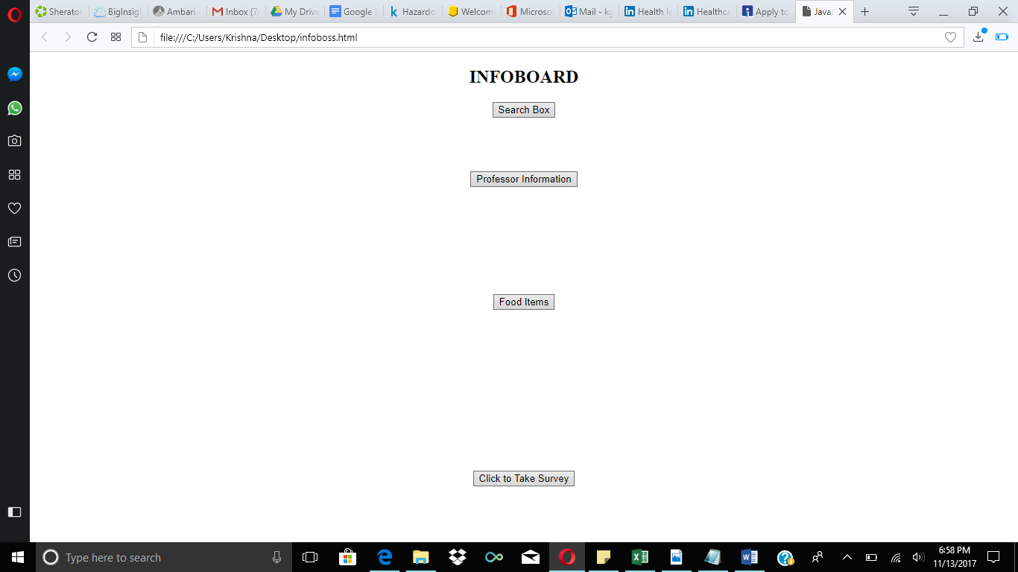Figure 4. First Prototype for InfoBoard

This prototype included “Search Box”, “Professor Information”, “Food Items”, and “Click to Take Survey” four selections for students to use. “Search box” will take you to Google.com so users can perform search. “Professor Information” will take you to a search directory for students to search for professor’s information. “Food Items” will show you the hours and menu of each restaurant at the food court. “Click to Take Survey” will take you to Survey Monkey to fill out a survey. Since this was a prototype to try out the codes and query, this prototype did not include a pretty picture, or fancy designs.

After this prototype, our engineers talked with everyone in the group to make sure this had the right elements that everyone agrees, and liked how the sections were prompting students to different information. Some sections then were modified and replaced. “Search Box” was removed due to complexity of linking and coding. We also did not want to provide users a search engine when their phone can easy do it. “Professor Information” was modified and updated to only the Information System department’s faculty will show up instead of the search directory. “Food Items” did not get an update or modification since it contained the right information. “Click to Take Survey” got modified since the original setting for Survey Monkey only lets one device fill out one response to cookies stored in browser. This will cause a lot of issue since only one user will be able to fill out the survey. Our engineers changed the setting to make sure that multiple surveys could be filled out on each device. “Analyze Results” section has been added. It generates the results from the survey. Administrators can click the section, and log in to get the results from the survey they decided to let students fill in.

1. Ideate

The final decision of the prototype was made between everyone. After engineers built the first prototype, we all sat down together. The engineers explained every section, and we decided how everything should be modified. A few sections got an upgrade, one section we decided not to include anymore, and one section stayed the same.

1. Prototype

Figure 5 is the final prototype that we have created after many changes, modifications, and consulting from our professor, and online resources. This final prototype is built on a combination between HTML and JAVA, and it is being polished with an attractive front page for users to catch their eyes. We have put big buttons on it, and since it is used at California State University, Los Angeles, we have included the school logo. The front page includes our product name - InfoBoard on it, with the four sections that users could use, and the school logo.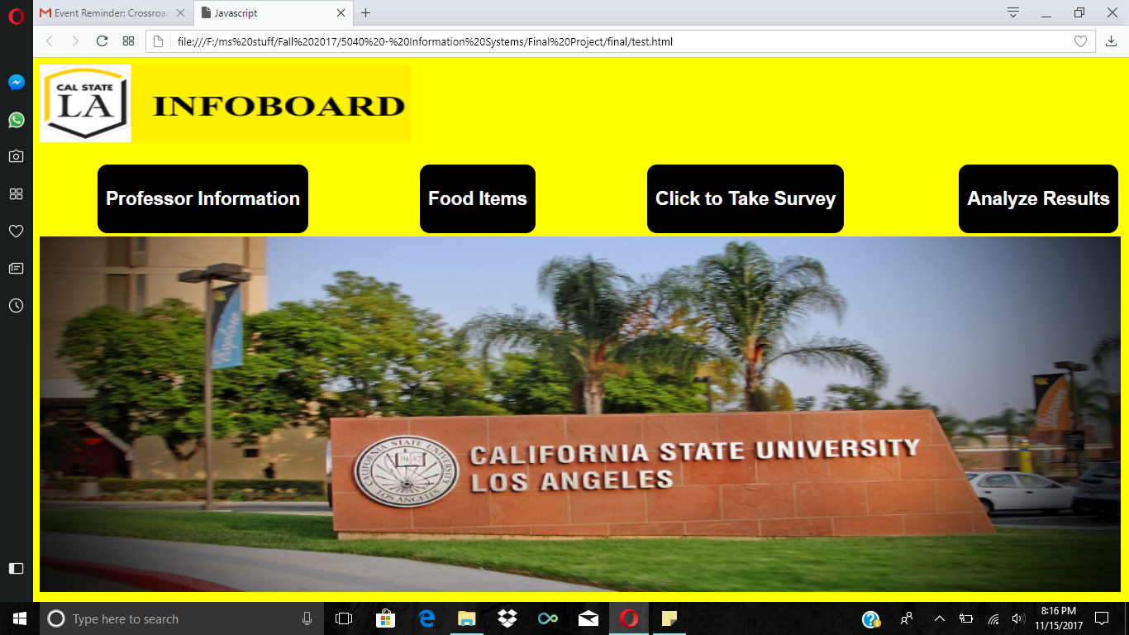

Figure 5. Final Prototype for InfoBoard

The first section is “Professor Information” (Figure 6. Professor Information). This section will show users information for professors, including office hours, office location, e-mail, and more details. As for right now, we are only including Information System Department Professors.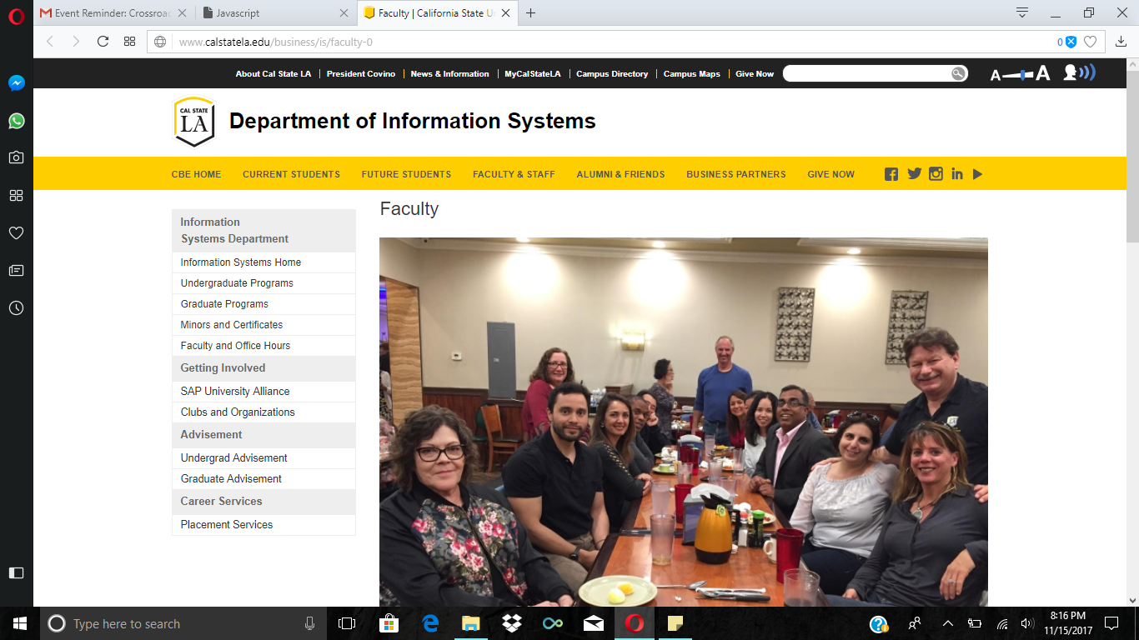

Figure 6. Professor Information

The second section is “Food Items” (Figure 7. Food Items). This section is where users will find the hours and menu for the restaurants in the food court. Instead of walking through the campus to find out that Carl’s Jr is not open 8:30 p.m. on a Monday after class, students can simply check on InfoBoard to see if they are open or not.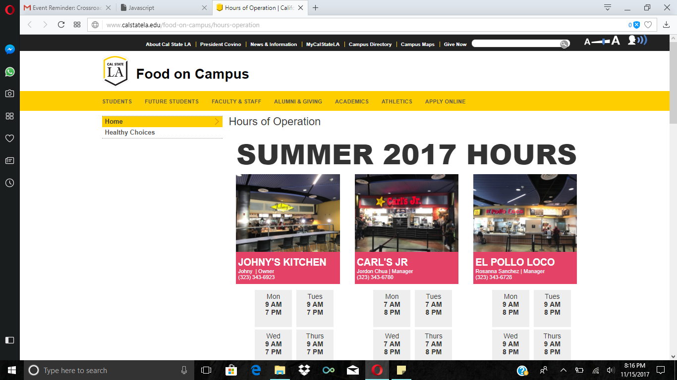

Figure 7. Food Items

The third section is “Click to Take Survey” (Figure 8. Click to Take Survey). This section allows users to fill out surveys helping clubs, professors, or students for their use. Clubs can use the survey to understand member/non-member’s preference. Students could use the survey to get results for their projects. Professors could use the survey to understand student more while students could fill the surveys out anonymous. 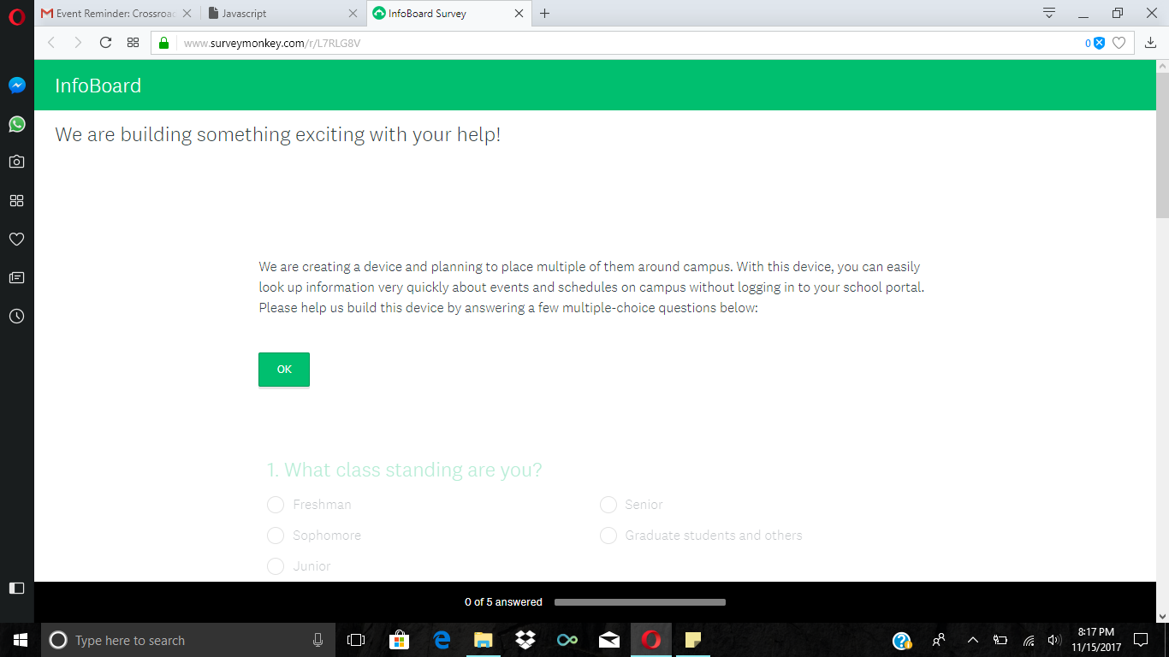

Figure 8. Click to Take Survey

The last section is “Analyze Results” (Figure 9. Analyze Results). This section is where the administrator of the survey could log in, and check the result of the survey. Surveys could be posted from different clubs, different professors, or students could request to post survey for their projects. Whoever requested to use the survey section will have administration rights for a certain period of time depending on how long they want their survey to be posted.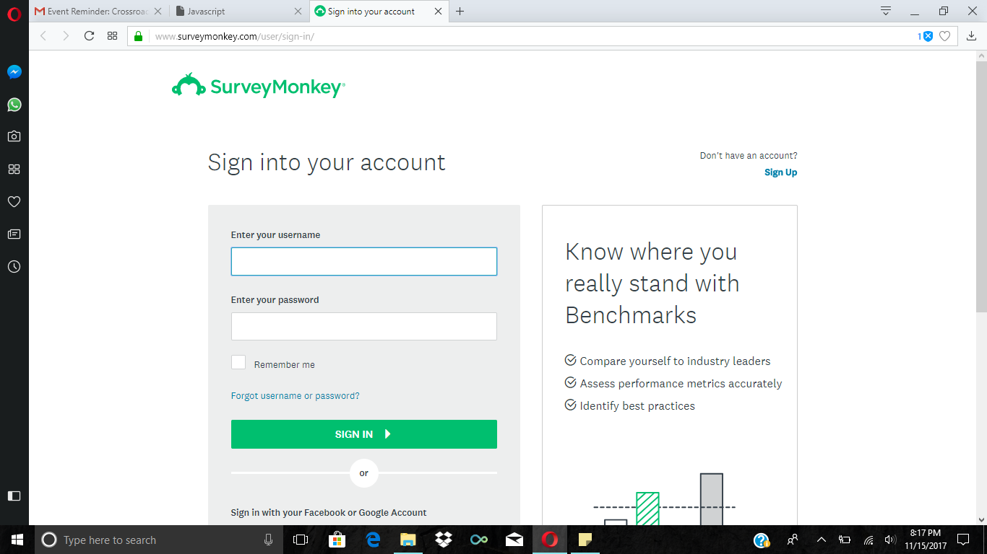

Figure 9. Analyze Results

This prototype is to make everything more convenient for students on campus, saving their time, and not increasing the awkwardness of talking to people.

1. Conclusion

For this project, we have created “InfoBoard” to save people’s time, and increase the efficiency of the users. Throughout the two months, we have had a lot of meetings, and discussed about every detail trying to make our product the best with the time given. Our product not only saves student’s time, but can also convenient professors, and even first time visitors that come to the campus can benefit from it. Our final prototype might not be perfect, but if we have given more time, we will definitely have our product at a hundred percent.

1. References
2. Nessler, D. (2016, May 19). How to apply a design thinking, HCD, UX or any creative process from scratch. Retrieved November 14, 2017, from <https://medium.com/digital-experience-design/how-to-apply-a-design-thinking-hcd-ux-or-any-creative-process-from-scratch-b8786efbf812>
3. HTML5 Tutorial. (n.d.). Retrieved November 14, 2017, from <https://www.w3schools.com/html/>
4. JavaScript Tutorial. (n.d.). Retrieved November 14, 2017, from <https://www.w3schools.com/js/default.asp>